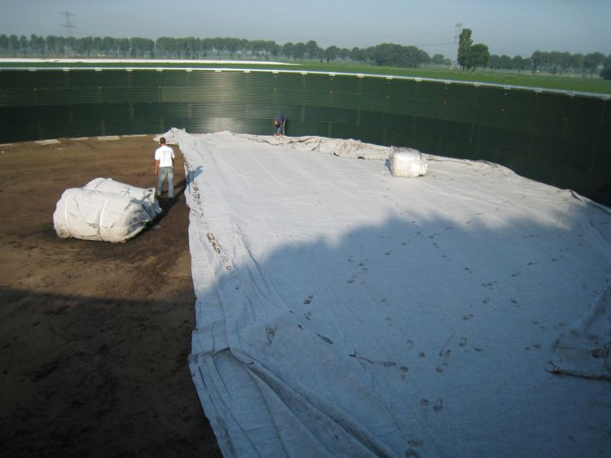
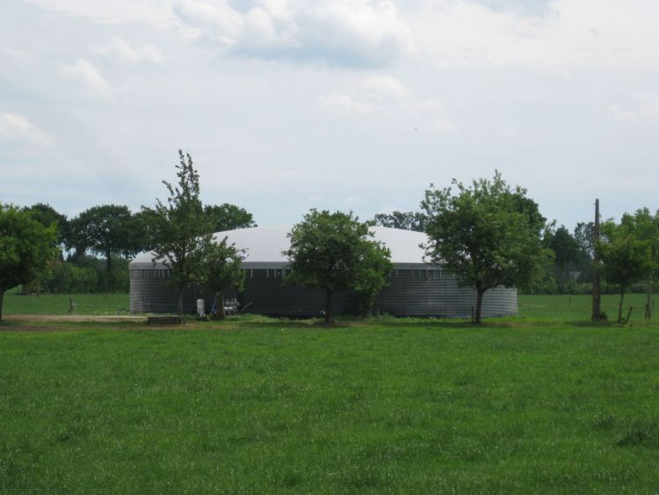
MONTOVANÉ AKUMULAČNÍ NÁDRŽE
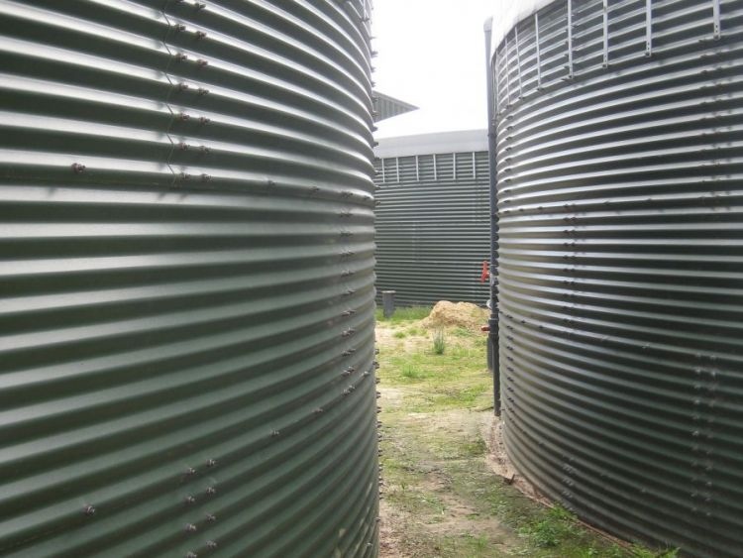
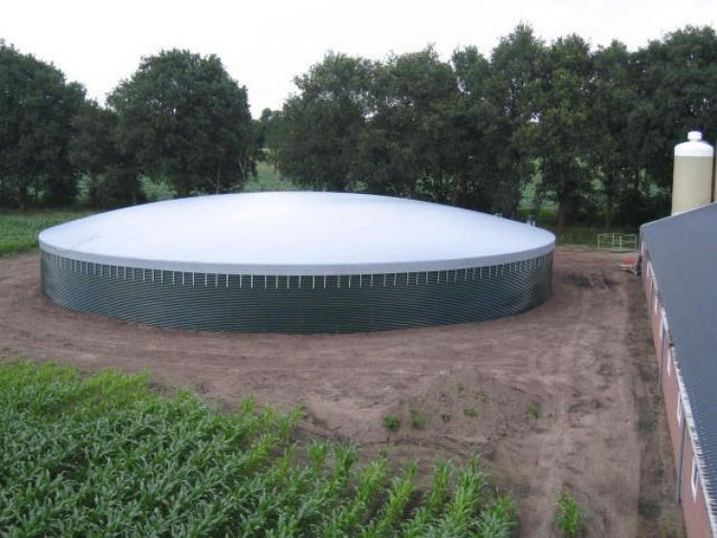
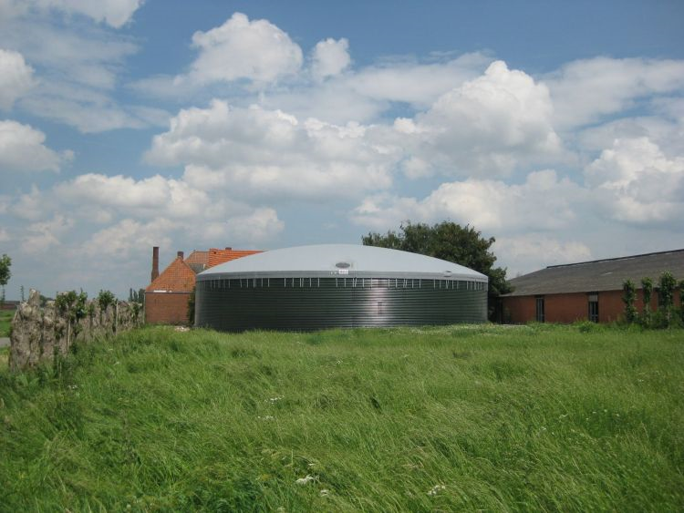
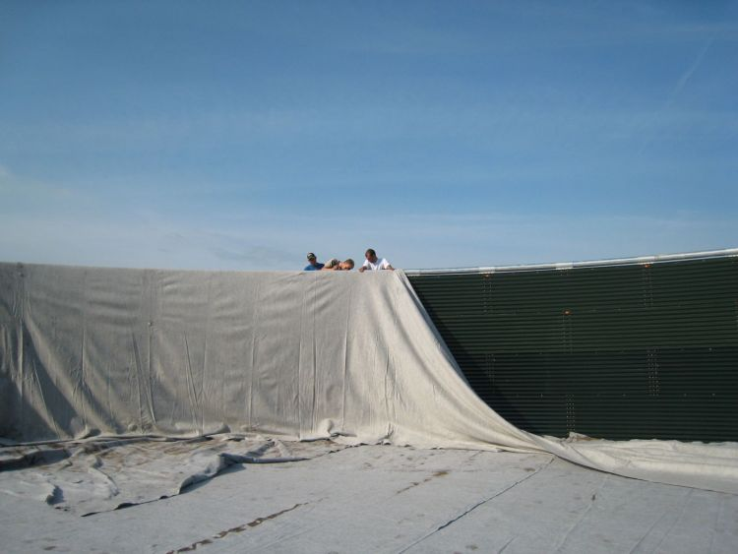
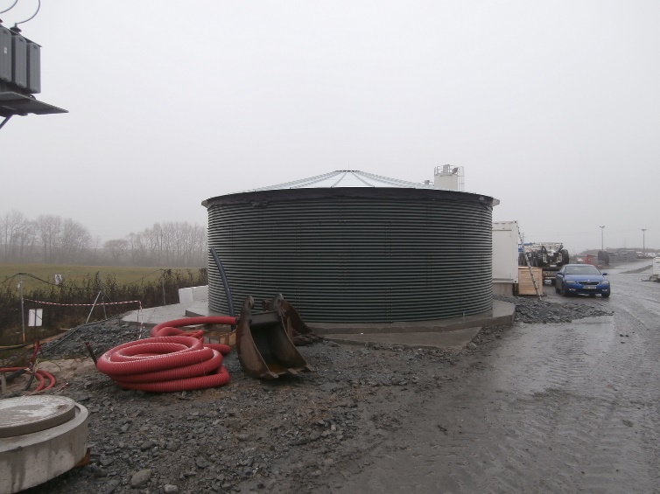
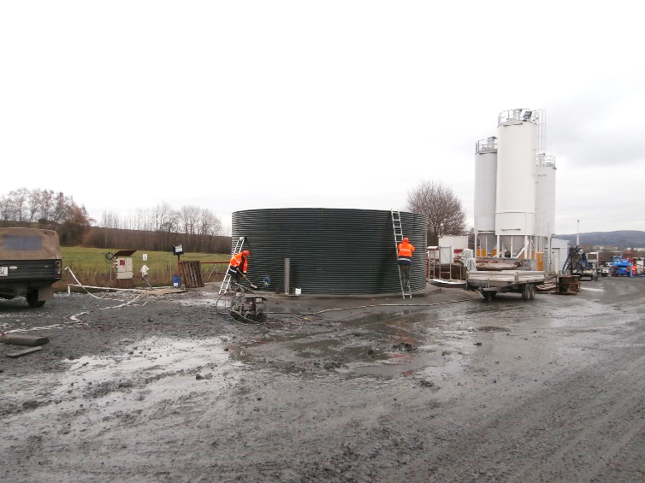
Využití
- zemědělství – zavlažování, skladování hnoje, kejdy
- zahradnictví – zavlažování, čištění vody
- akvakultura – zásobníky pro chov ryb se systémem recirkulace vody
- průmysl – úprava odpadní vody za užití krytých nádrží
- nádrže na pitnou vodu
Nádrže
- modulární pozinkované ocelové nádrže z vlnitého plechu o tloušťce
1–1,2 mm
- objem 2m³ až 2000m³
- rozměr nádrží 1,83m x 0,76m až 34m x 4,57m (průměr x výška)
- plovoucí či plechová víka na nádrže
- izolační folie do nádrží (PVC, EPDM, EX)
Výhody
- jednoduchá montáž s pomocí ručního nářadí
- doprava uzpůsobena paletové manipulaci
- všestranné využití, různá provedení
- odolnost

Průměr [m] | Výška [m] | Objem [m³] | Průměr [m] | Výška [m] | Objem [m³] | Průměr [m] | Výška [m] | Objem [m³]
1,34 | 1,59 | 2 | 4,03 | 0,81 | 10 | 7,39 | 0,81 | 35
1,34 | 2,36 | 3 | 4,08 | 1,60 | 33,97 | 8,06 | 1,59 | 81
1,34 | 3,12 | 4 | 4,19 | 2,37 | 35,19 | 8,06 | 2,36 | 120
1,34 | 3,88 | 5 | 4,30 | 3,164 | 36,41 | 8,06 | 3,12 | 159
1,34 | 4,64 | 7 | 4,41 | 3,240 | 37,63 | 8,06 | 3,88 | 198
1,34 | 5,37 | 8 | 4,70 | 2,36 | 41 | 8,06 | 4,64 | 237
1,34 | 0,81 | 1 | 4,70 | 3,12 | 54 | 8,06 | 5,37 | 274
2,01 | 1,59 | 5 | 4,70 | 3,88 | 67 | 8,06 | 6,13 | 312
2,01 | 2,36 | 7 | 4,70 | 4,64 | 81 | 8,06 | 0,81 | 41
2,01 | 3,12 | 10 | 4,70 | 5,37 | 93 | 8,73 | 1,59 | 95
2,01 | 3,88 | 12 | 4,70 | 1,59 | 28 | 8,73 | 2,36 | 141
2,01 | 4,64 | 15 | 4,70 | 0,81 | 14 | 8,73 | 3,12 | 187
2,01 | 5,37 | 17 | 5,37 | 1,59 | 36 | 8,73 | 3,88 | 232
2,01 | 0,81 | 3 | 5,37 | 2,36 | 53 | 8,73 | 4,64 | 278
2,69 | 1,59 | 9 | 5,37 | 3,12 | 71 | 8,73 | 5,37 | 321
2,69 | 2,36 | 13 | 5,37 | 3,88 | 88 | 8,73 | 0,81 | 48
2,69 | 3,12 | 18 | 5,37 | 4,64 | 105 | 9,40 | 1,59 | 110
2,69 | 3,88 | 22 | 5,37 | 5,37 | 122 | 9,40 | 2,36 | 164
2,69 | 4,64 | 26 | 5,37 | 6,13 | 138 | 9,40 | 3,12 | 217
2,69 | 5,37 | 31 | 5,37 | 0,81 | 18 | 9,40 | 3,88 | 269
2,69 | 0,81 | 5 | 6,04 | 1,59 | 46 | 9,40 | 4,64 | 322
3,36 | 1,59 | 14 | 6,04 | 2,36 | 68 | 9,40 | 5,37 | 373
3,36 | 2,36 | 21 | 6,04 | 3,12 | 89 | 9,40 | 0,81 | 56
3,36 | 3,12 | 28 | 6,04 | 3,88 | 111 | 10,07 | 1,59 | 127
3,36 | 3,88 | 34 | 6,04 | 4,64 | 133 | 10,07 | 2,36 | 188
3,36 | 4,64 | 41 | 6,04 | 5,37 | 154 | 10,07 | 3,12 | 248
3,36 | 5,37 | 48 | 6,04 | 0,81 | 23 | 10,07 | 3,88 | 309
3,36 | 0,81 | 7 | 6,72 | 1,59 | 56 | 10,07 | 4,64 | 370
3,42 | 1,60 | 26,63 | 6,72 | 2,36 | 84 | 10,07 | 5,37 | 428
3,53 | 2,37 | 27,86 | 6,72 | 3,12 | 111 | 10,07 | 0,81 | 65
3,64 | 3,16 | 29,08 | 6,72 | 3,88 | 138 | 10,75 | 1,59 | 144
3,75 | 3,24 | 30,30 | 6,72 | 4,64 | 165 | 10,75 | 2,36 | 214
3,86 | 4,65 | 31,52 | 6,72 | 5,37 | 190 | 10,75 | 3,12 | 283
3,97 | 5,38 | 32,74 | 6,72 | 0,81 | 29 | 10,75 | 3,88 | 352
4,03 | 1,59 | 20 | 7,39 | 1,59 | 68 | 10,75 | 4,64 | 421
4,03 | 2,36 | 30 | 7,39 | 2,36 | 101 | 10,75 | 5,37 | 487
4,03 | 3,12 | 40 | 7,39 | 3,12 | 134 | 10,75 | 0,81 | 74
4,03 | 3,88 | 49 | 7,39 | 3,88 | 166 | 11,42 | 1,59 | 163
4,03 | 4,64 | 59 | 7,39 | 4,64 | 199 | 11,42 | 2,36 | 242
4,03 | 5,37 | 68 | 7,39 | 5,37 | 230 | 11,42 | 3,12 | 320
Nádrže dodáváme v těchto rozměrech

Průměr [m] | Výška [m] | Objem [m³] | Průměr [m] | Výška [m] | Objem [m³] | Průměr [m] | Výška [m] | Objem [m³]
11,42 | 3,88 | 397 | 15,45 | 1,59 | 298 | 18,81 | 0,81 | 225
11,42 | 4,64 | 475 | 15,45 | 2,36 | 442 | 18,81 | 5,37 | 1492
11,42 | 5,37 | 550 | 15,45 | 3,12 | 585 | 19,48 | 1,59 | 474
11,42 | 0,81 | 83 | 15,45 | 3,88 | 727 | 19,48 | 2,36 | 703
12,09 | 1,59 | 183 | 15,45 | 4,64 | 870 | 19,48 | 3,12 | 930
12,09 | 2,36 | 271 | 15,45 | 5,37 | 1007 | 19,48 | 3,88 | 1156
12,09 | 3,12 | 358 | 15,45 | 0,81 | 152 | 19,48 | 0,81 | 241
12,09 | 3,88 | 445 | 16,12 | 1,59 | 325 | 19,48 | 4,64 | 1383
12,09 | 4,64 | 533 | 16,12 | 2,36 | 482 | 19,48 | 5,37 | 1600
12,09 | 5,37 | 616 | 16,12 | 3,12 | 637 | 20,15 | 1,59 | 507
12,09 | 0,81 | 93 | 16,12 | 3,88 | 792 | 20,15 | 2,36 | 753
12,09 | 6,13 | 704 | 16,12 | 4,64 | 947 | 20,15 | 3,12 | 995
12,76 | 1,59 | 203 | 16,12 | 5,37 | 1096 | 20,15 | 3,88 | 1237
12,76 | 2,36 | 302 | 16,12 | 0,81 | 165 | 20,15 | 0,81 | 258
12,76 | 3,12 | 399 | 16,79 | 1,59 | 352 | 20,15 | 4,64 | 1480
12,76 | 3,88 | 496 | 16,79 | 2,36 | 523 | 20,82 | 1,59 | 541
12,76 | 4,64 | 593 | 16,79 | 3,12 | 691 | 20,82 | 2,36 | 803
12,76 | 5,37 | 687 | 16,79 | 3,88 | 859 | 20,82 | 3,12 | 1062
12,76 | 0,81 | 104 | 16,79 | 4,64 | 1027 | 20,82 | 0,81 | 276
13,43 | 1,59 | 225 | 16,79 | 5,37 | 1189 | 20,82 | 3,88 | 1321
13,43 | 2,36 | 334 | 16,79 | 0,81 | 179 | 20,82 | 4,64 | 1580
13,43 | 3,12 | 442 | 17,46 | 1,59 | 381 | 21,49 | 1,59 | 577
13,43 | 3,88 | 550 | 17,46 | 2,36 | 565 | 21,49 | 2,36 | 856
13,43 | 4,64 | 657 | 17,46 | 3,12 | 747 | 21,49 | 3,12 | 1132
13,43 | 5,37 | 761 | 17,46 | 3,88 | 929 | 21,49 | 0,81 | 294
13,43 | 0,81 | 115 | 17,46 | 4,64 | 1111 | 21,49 | 3,88 | 1407
14,10 | 1,59 | 248 | 17,46 | 5,37 | 1286 | 21,49 | 4,64 | 1683
14,10 | 2,36 | 369 | 17,46 | 0,81 | 194 | 22,16 | 1,59 | 613
14,10 | 3,12 | 487 | 18,13 | 1,59 | 410 | 22,16 | 2,36 | 910
14,10 | 3,88 | 606 | 18,13 | 2,36 | 609 | 22,16 | 3,12 | 1203
14,10 | 4,64 | 725 | 18,13 | 3,12 | 805 | 22,16 | 0,81 | 312
14,10 | 5,37 | 838 | 18,13 | 3,88 | 1002 | 22,16 | 3,88 | 1496
14,10 | 0,81 | 126 | 18,13 | 4,64 | 1198 | 22,16 | 4,64 | 1790
14,78 | 1,59 | 273 | 18,13 | 5,37 | 1386 | 22,84 | 1,59 | 651
14,78 | 2,36 | 405 | 18,13 | 0,81 | 209 | 22,84 | 2,36 | 967
14,78 | 3,12 | 535 | 18,81 | 1,59 | 442 | 22,84 | 3,12 | 1278
14,78 | 3,88 | 666 | 18,81 | 2,36 | 656 | 22,84 | 0,81 | 332
14,78 | 4,64 | 796 | 18,81 | 3,12 | 867 | 22,84 | 3,88 | 1590
14,78 | 5,37 | 921 | 18,81 | 3,88 | 1078 | 22,84 | 4,64 | 1901
14,78 | 0,81 | 139 | 18,81 | 4,64 | 1289 | 23,51 | 1,59 | 690

Průměr [m] | Výška [m] | Objem [m³] | Průměr [m] | Výška [m] | Objem [m³] | Průměr [m] | Výška [m] | Objem [m³]
23,51 | 2,36 | 1024 | 28,88 | 2,36 | 1546
23,51 | 3,12 | 1354 | 28,88 | 0,81 | 531
23,51 | 0,81 | 352 | 28,88 | 3,88 | 2542
23,51 | 3,88 | 1684 | 29,55 | 1,59 | 1090
23,51 | 4,64 | 2014 | 29,55 | 2,36 | 1619
24,18 | 1,59 | 730 | 29,55 | 3,12 | 2139
24,18 | 2,36 | 1084 | 29,55 | 0,81 | 556
24,18 | 3,12 | 1433 | 29,55 | 3,88 | 2661
24,18 | 0,81 | 372 | 30,22 | 1,59 | 1140
24,18 | 3,88 | 1782 | 30,22 | 2,36 | 1693
24,18 | 4,64 | 2131 | 30,22 | 1,59 | 1140
24,85 | 1,59 | 771 | 30,22 | 2,36 | 1693
24,85 | 2,36 | 1145 | 30,22 | 0,81 | 581
24,85 | 3,12 | 1513 | 30,22 | 3,88 | 2783
24,85 | 0,81 | 393 | 30,90 | 1,59 | 1192
24,85 | 3,88 | 1882 | 30,90 | 2,36 | 1770
25,52 | 1,59 | 813 | 30,90 | 0,81 | 607
25,52 | 2,36 | 1207 | 30,90 | 3,88 | 2910
25,52 | 1,59 | 813 | 31,57 | 0,81 | 634
25,52 | 2,36 | 1207 | 31,57 | 1,59 | 1245
25,52 | 0,81 | 414 | 31,57 | 2,36 | 1847
25,52 | 3,88 | 1985
26,19 | 1,59 | 857
26,19 | 2,36 | 1271
26,19 | 0,81 | 436
26,19 | 3,88 | 2090
26,87 | 1,59 | 902
26,87 | 2,36 | 1338
26,87 | 0,81 | 459
26,87 | 3,88 | 2200
27,54 | 1,59 | 947
27,54 | 2,36 | 1406
27,54 | 0,81 | 483
27,54 | 3,88 | 2311
28,21 | 1,59 | 994
28,21 | 2,36 | 1475
28,21 | 3,12 | 1950
28,21 | 0,81 | 506
28,21 | 3,88 | 2425
28,88 | 1,59 | 1042

